**Introduction**

* Antipredator decision-making has received much attention in ecology during the last decade.
* Preys often decrease their activity or use different spatial or temporal refuges to decrease their vulnerability to predators.
* *Parabuthus transvaalicus* scorpions have been shown to regulate defensive venom expenditure based on perceived risk.
* Due to the unforgiving nature of predation, prey organisms are under strong selection to detect and avoid predators. Many organisms benefit from the use of multiple sensory inputs including: visual cues, substrate-borne vibration, and chemical or tactile stimulations.
* There is little information on scorpions using chemosensory cues in predator avoidance, but a few studies have suggested that some species my use substrate-borne pheromones for recognition of female conspecifics.
* Scorpions possess a large assortment of mechano- and chemoreceptors that provide them with information from the environment
* To date no study has investigated scorpion behavior response to chemical cues

**Objective**

Investigate whether the odors from a predator might influence the defensive behavior of *Hadrurus arizonensis*, and if the scorpion size plays a role in the type of response.

**Method**

* We tested the scorpions under two threat conditions by inducing them to sting a parafilm covered cup in the presence or absence of odors from a potential rodent predator (*Mus musculus*).
* Reaction time was measured as well as probes needed to induce a reaction.
* We also measured wet vs. dry stings.
* For experimental setup refer to figure 1

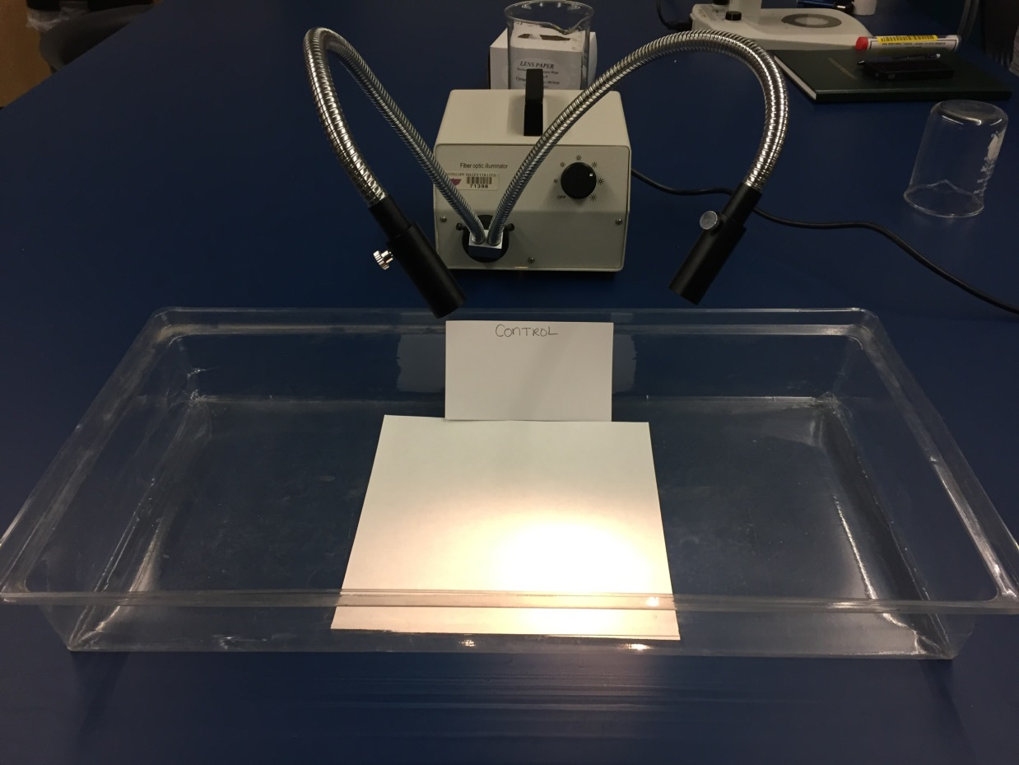

Figure 1: Picture of the setup used to test each scorpion. (Enclosed container, Fiber optic light source, Filter paper- scented or unscented).

Post Info

Scorpion is on paper (uncented or scented). A parifilm covered object is lowered down and touched to the head of the scorpion. This act is called a “probe” so the number of probes until a reaction is what is measured. Also the time elapsed from first probe until the reaction, and the volume of venom in the case it the reaction was a “wet sting”.

